Gavin – Beginners/Intermediate new COGS’ session.
For a while now and with the increase in attendees to the Beginners’ session of COGS, it has become clear that some of our COGS are no longer beginners! With some of our women who have attended for a few years, it was felt a while ago, that it was time to introduce a new session which would cater for the beginners who were now capable of moving in the direction of intermediate players. Having asked the Crawley Community Foundation for an extra session, it became clear that this wasn’t possible and therefore, as a Committee, we decided to introduce our own, inaugural COGS’ Beginners/Intermediate session, with a new coach.
Having run some additional coaching sessions previously, for our COGS outside our usual sessions, Gavin Gordon was asked to come and join us. Gavin, has a great rapport with the COGS he’s already coached and is well respected by them, so he was the ideal choice to ask! Gavin was delighted to join us and we spoke a bit more in depth to find out what he would bring to this new session.
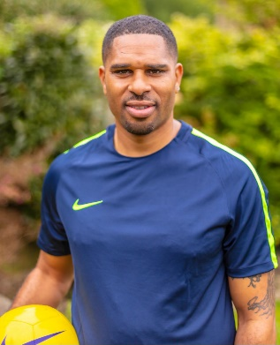
CB: Gavin, it’s great to confirm that you will be officially coaching the new beginners/intermediate session for the COGS. How long have you been coaching for and where did it all start?
GG: I have been coaching for 7 years now and started in youth football, first. I then progressed into a senior level for men’s semi-professional football with Redhill, for 4 years.
CB: What have you been doing in the last year?
GG: For the last year, I have also been coaching for Chelsea Foundation at youth level. Whilst coaching there, I have also been doing regular one to one sessions for various ages and abilities.
CB: How did you hear about the COGS?
GG: Through doing these sessions, I was approached to coach some of the COGS (who are parents) on a regular basis, to help them develop their technical skills and confidence to become better players.
CB: How do you coach your sessions?
GG: My sessions are always planned for the ability of the group or individual. Whilst I seek to improve their technical, physical and game related approach within my practices, I also work to build up their confidence and mindset as a player to achieve their goals, while also creating a fun, learning environment for them.
CB: How was your own journey, playing football?
GG: Personally, I have been involved and around football for as long as I can remember. I started as a youth player and then transitioned into senior semi-professional men’s football.
CB: How do you see your role with the COGS?
GG: I’m very passionate about the game and keen for anyone I come into contact with to learn and improve, as well as enjoy their football experience with me. I’m always interested in learning new things and trying to improve and adapt to be the best coach I can possibly be, along the way. We are going to have a great deal of fun and I’m really looking forward to starting my new role.
CC: Thanks, Gavin! We’re really looking forward to you joining us.

The new Beginners/Intermediate session will take place after the existing Beginners’ session at the 3G at Crawley Town FC, once all our sessions run by the Crawley Town Community Foundation have started up again. Watch this space!

